Software Requirements Specification
For
“Vobitax”
Version 1.0 approved
Prepared by Ofir Attia

23/03/15
Table of Contents
Table of Contents ii
Revision History ii
1. Introduction 1
1.1 Purpose 1
1.2 Document Conventions 1
1.3 Intended Audience and Reading Suggestions 1
1.4 Product Scope 1
1.5 References 1
2. Overall Description 2
2.1 Product Perspective 2
2.2 Product Functions 2
2.3 User Classes and Characteristics 2
2.4 Operating Environment 2
2.5 Design and Implementation Constraints 2
2.6 User Documentation 2
2.7 Assumptions and Dependencies 3
3. External Interface Requirements 3
3.1 User Interfaces 3
3.2 Hardware Interfaces 3
3.3 Software Interfaces 3
3.4 Communications Interfaces 3
4. System Features 4
4.1 System Feature 1 4
4.2 System Feature 2 (and so on) 4
5. Other Nonfunctional Requirements 4
5.1 Performance Requirements 4

Revision History
Name | Date | Reason For Changes | Version

Introduction

Purpose
VoIP is simple Push-To-Talk Java based application for gamers.
- Voice communication with multiple people.
- Cross channel communications.
- Muted channels.
- Portable cross platform server.

Document Conventions
Document will be written wtih Times font.

Intended Audience and Reading Suggestions
The following document for:
- Programmers
- Marketing staff

Product Scope
See 1.1

References
None.

Overall Description

Product Perspective
As part of larger project for “Clans\Team Management” in online games. The following product “Vobitax” intend for gamers who wants to communicate while they are playing.
“Vobitax” is simple “Voice Over Internet Protocol” application.

Product Functions
  - Server have limited number of rooms.
  - Each team get server and a client to connect it.
  - User able to switch rooms in the server.
  - Client based Push-To-Talk VoIP.

User Classes and Characteristics
- Gamers
- People who use VoIP ( Skype, Ventrilo, Teamspeak ) to communicate each other.

Operating Environment
- Vobitax is a Cross-Platform application ( Java based ).
- Vobitax used the internal mic and speaker of the user.

Design and Implementation Constraints
“Vobitax” is a VoIP applicated based UDP\TCP protocol.
Problems that can come across them are problems of syncing between different threads , because each user logs on to the system is a process . The software will have to manage these processes and their messaging between them (eg voice message - server will have to make a broadcast to everyone in a particular room ) .

User Documentation
- Client : Client_Manual.pdf
- Server : Server_Manual.pdf

Assumptions and Dependencies
“Vobitax” is independent application.

External Interface Requirements

User Interfaces

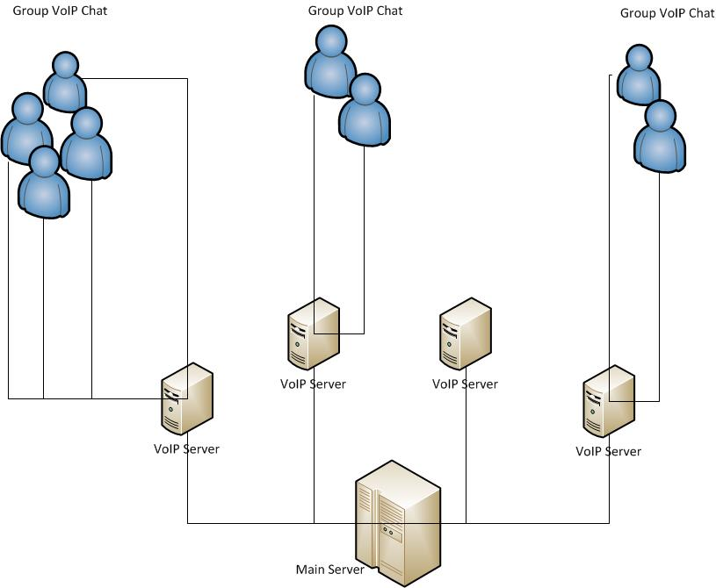

Hardware Interfaces
- Internal Microphone ( Built-in \ Headphones )
- Internal Speakers \ Headphones
- Sound Card

Software Interfaces
- Cross-Platform Operating System ( JAVA Based Application ).
- jNativeHook – JNI Library ( EventListener from OS ).
- Network Libraries – java.net
- Protocols – TCP\UDP

Communications Interfaces
“Vobitax” Server ( Handle TCP\UDP connections )

System Features

Message-Passing Client\Server
User is able to switch between rooms,change his name and Push-To-Talk

Other Nonfunctional Requirements

Performance Requirements
- To be able to use “Vobitax” and play simultaneous the internet speed needs to be at least 5Mbps.

